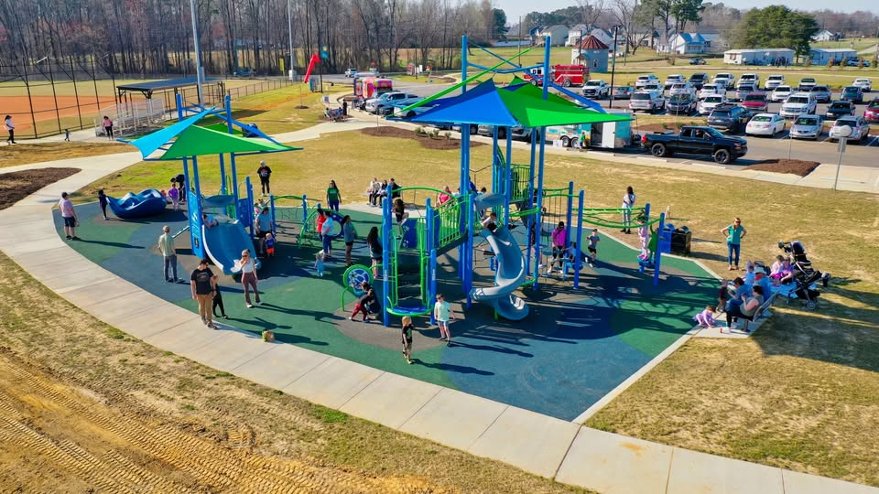

JOIN OUR TEAM!

The Town of Archer Lodge is seeking to fill a part-time position as Athletic Supervisor. This o

The Town of Archer Lodge is seeking to fill a part-time position as Athletic Aide. This position performs under the supervision and evaluated by the Parks and Recreation Director and Athletic Supervisor. This position will remain open until filled. Anyone interested in applying can do so by completing the electronic application on the town’s website at https://www.archerlodgenc.gov or https://www.archerlodgenc.gov/jobs.

A person in this position performs routine clerical work to include keeping score sheets and time clocks for youth and adult sports, with general maintenance duties. Work requires flexible, year-round schedule as predetermined monthly hours include weekday evenings, as well as Saturday and Sundays and performed during all seasons.

Work involves performing routine tasks such as locking and unlocking facilities for athletic practices and games, acting as the point of contact for the public while at the facility, setting up fields and other assigned venues, and including working with leagues and tournaments.

Some additional essential duties include handling difficult situations involving players, coaches, and spectators during assigned shift; keeps score reports, results forms, playing times sheets, accident/incident report forms, and ensures the accuracy of reports filled out by other athletic aides; ensuring scheduled games and practices begin an end on time; administering first aid supplies; communicating issues with other town staff, officials, and emergency personnel; assist with cleaning facilities; enforcing town policies, and other duties as assigned.

Required knowledge skills and abilities include, basic working knowledge of major sports such as baseball, football, softball, and some knowledge of other sports; ability to work well with others; ability to communicate effectively, orally and in writing; and ability to resolve conflicts and negotiate while handling disputes or conflicts

Physical requirements include ability to physically perform basic life operational functions of climbing, balancing, stooping, kneeling, crouching, reaching, standing, walking, pushing, lifting, fingering, grasping, talking, hearing, and repetitive motions. Must be able to perform medium work exerting up to fifty pounds of force occasionally and/ up to twenty pounds of force frequently. Must possess the visual acuity to prepare and analyze data, operate time devices, and utilize measuring devices.

Other requirements include being at least 16 years of age at time of application, and ability to successfully pass an NC SBI and FBI fingerprint background investigation.

Current rate of pay is $12.00 per hour, paid on a bi-weekly basis via direct deposit.

