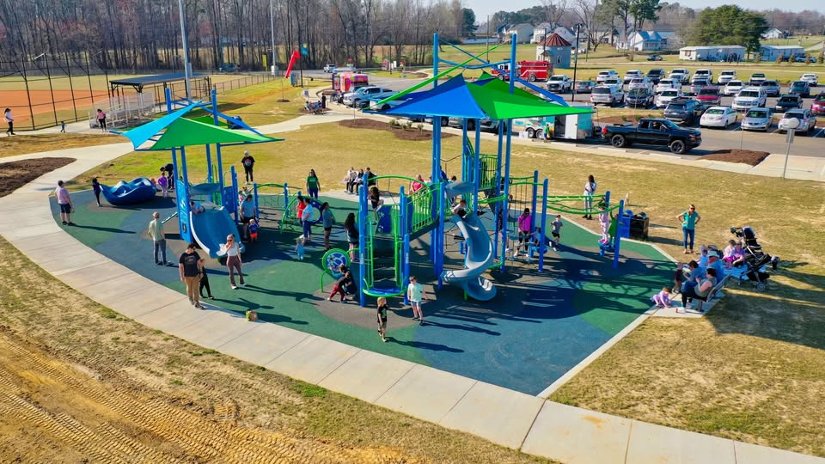

JOIN OUR TEAM!

The Town of Archer Lodge is seeking to fill a part-time position as Athletic Supervisor. This o

PART-TIME EMPLOYMENT OPPORTUNITY
Executive Assistant
The Town of Archer Lodge, NC

The Town of Archer Lodge is seeking a qualified, motivated individual to fill the part-time position of Executive Assistant. This position operates under the direct supervision of and is evaluated by the Assistant Town Administrator/Finance Officer.

Compensation & Hours
- Salary: Up to $20.00 hourly (Subject to experience)
- Hours: Maximum of 20 hours per week
- Recruitment: Position open until filled.
If interested in applying, you can do so by completing the electronic application on the town’s website at https://www.archerlodgenc.gov or https://www.archerlodgenc.gov/jobs.

The Executive Assistant performs intermediate-skilled and paraprofessional clerical and administrative work. This role involves assisting with a variety of complex office tasks, providing support to the Administration, and helping other town departments as assigned. The work requires a solid knowledge of municipal functions, use of considerable judgment, and independent action.

Essential Duties and Responsibilities
- Public Relations: Greet the public, answer phones, and direct inquiries to the appropriate personnel.
- Digital Media Management: Manage the Town’s website, electronic signage, and social media platforms (Facebook, X/Twitter, Instagram, etc.).
- Office Operations: Manage incoming/outgoing mail, perform banking tasks, manage purchasing, and maintain inventory.
- Event & Board Support: Assist with event planning, elected officials, and various boards (i.e., Planning Board, Board of Adjustment, and Code Enforcement) as needed.
- Financial Assistance: Support financial oversight, reporting, reconciliation, annual audit preparation, and budget processes as needed.

Required Knowledge, Skills, and Abilities
- Software Proficiency: Microsoft Word, Outlook, Excel, PowerPoint, SharePoint, Teams, Zoom, Webex, Adobe Acrobat, Canva, Social Media platforms, and Email/Contact Management. Ability to learn new software as required.
- Financial & Analytical: Basic knowledge of accounting, strong attention to detail, and the ability to keep accurate records and prepare reports.
- Communication: Ability to develop and maintain effective working relationships with staff, community groups, elected/appointed officials, the Governing Body, Planning Board, and the Board of Adjustment.
- Independence: Strong ability to perform tasks independently using knowledge of modern office equipment and practices.

Desirable Education and Experience
- Minimum of a two-year associate degree in municipal government, office technology, business, or a related field, along with experience in office administrative work.
- An equivalent combination of education and experience sufficient to perform the essential functions will be considered.

Physical & Additional Requirements
- Physical Demands: Must be able to physically perform basic life operational functions, including climbing, balancing, stooping, kneeling, crouching, crawling, reaching, standing, walking, pushing, pulling, lifting, fingering, grasping, talking, hearing, and repetitive motions.
- Strength & Visual Acuity: Must be able to perform medium work, exerting up to ten pounds of force. Must possess visual acuity to prepare and analyze data, operate computers and electronic devices, do extensive reading, and perform visual inspections.

